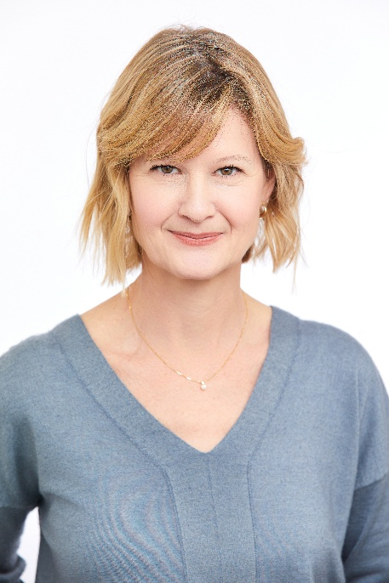

Susan Hazels Mitmesser, PhD
CSO, MeriCal

Dr. Mitmesser leads strategic initiatives at MeriCal, driving research, innovation, and product development while upholding the highest standards of scientific integrity across the organization. She has a passion for nutrition and wellness and leverages her ability to communicate scientific findings to consumers and the marketplace.
Dr. Mitmesser brings extensive experience in research, nutrition biochemistry, and manufacturing, with a career spanning food, dietary supplements, over the counter, and infant formula. She operates at the nexus of academia, clinical research, industry, manufacturing, and regulatory affairs, bridging disciplines to advance scientific innovation. Dr. Mitmesser serves on the Editorial Board of four peer-reviewed journals and has published in many peer-reviewed journals and is a contributing author for book chapters relating to nutrition in adult and pediatric populations.
Dr. Mitmesser is an active member of the American Society of Nutrition, the American Association for the Advancement of Science, and the New York Academy of Sciences. She also serves on the Senior Scientific Advisory Council for the Council for Responsible Nutrition. She holds a PhD in Human Nutrition from the University of Nebraska.

